Problems: 2.4, 2.6, 2.13, 2.17, 2.19

2.4

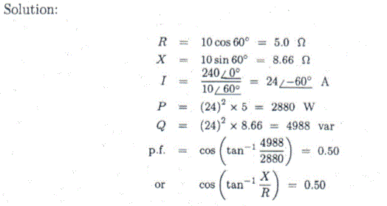

2.6

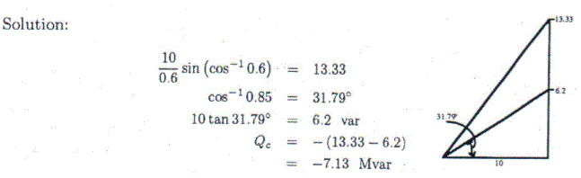

2.13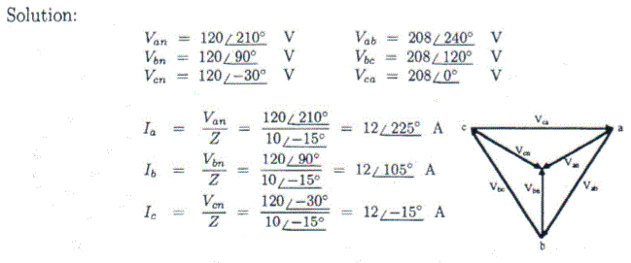

2.17

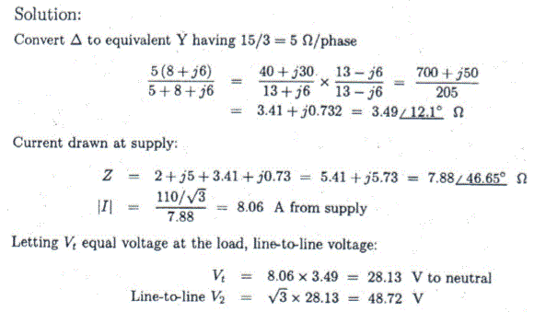

2.19

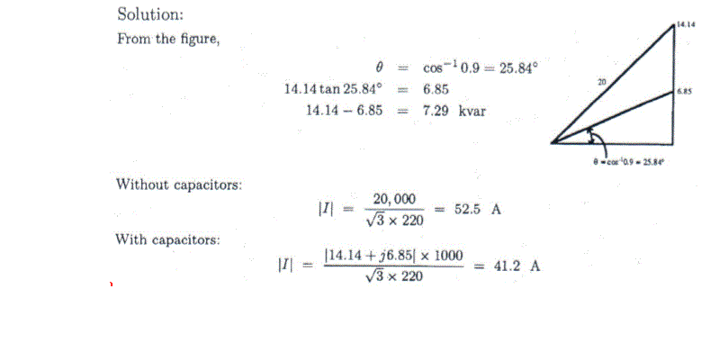

Problems: 3.6, 3.10, 3.12, 3.16, 3.19 3.27, 3.31, 3.33(a)

3.6

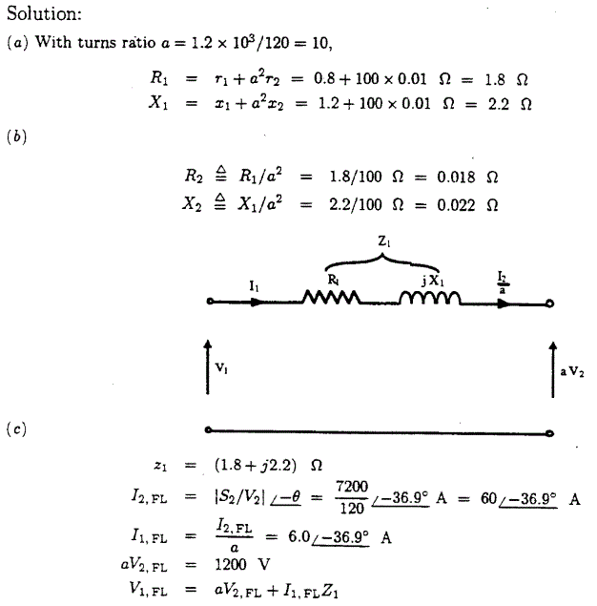

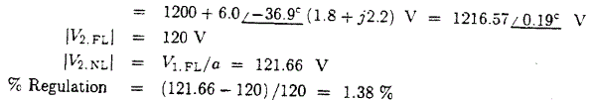

3.10

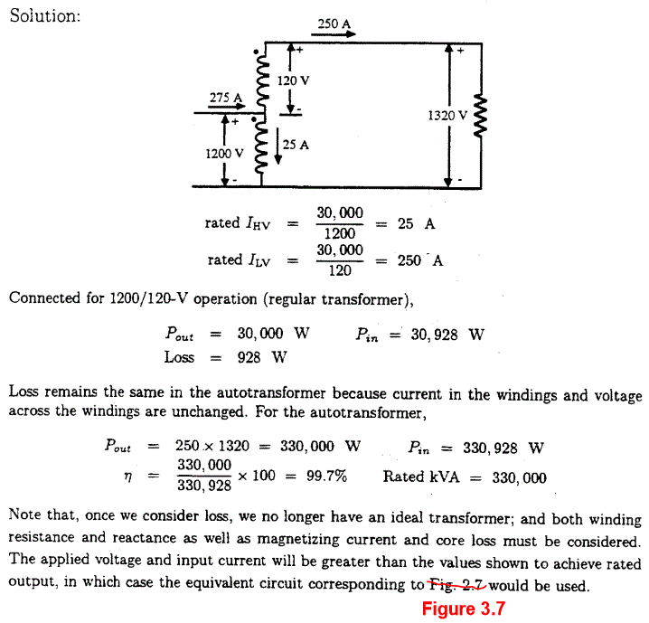

3.12

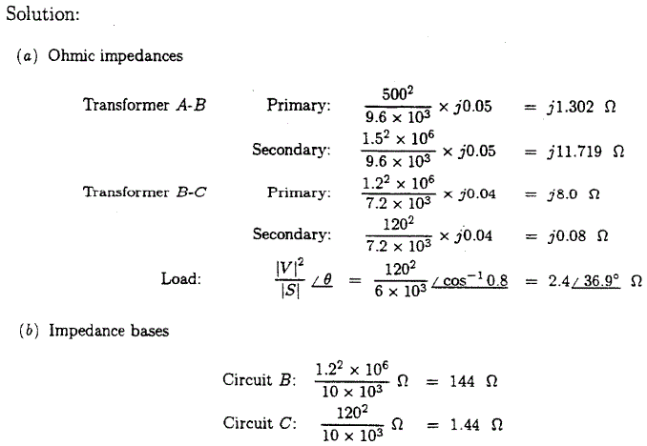

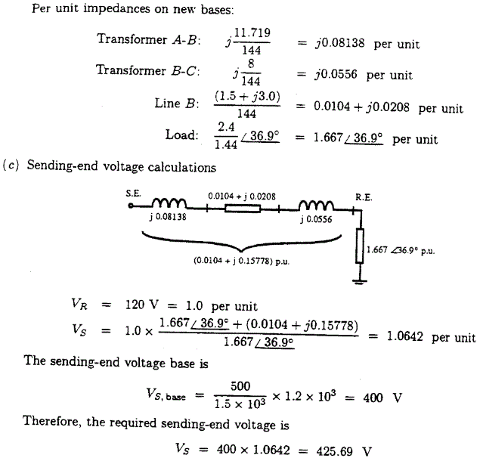

3.16

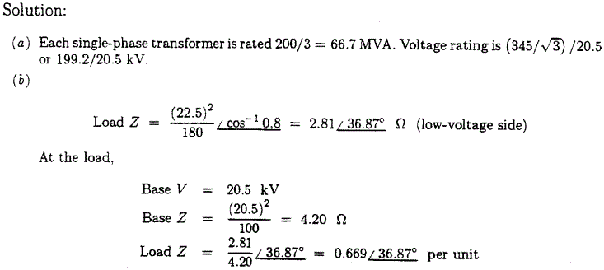

3.19

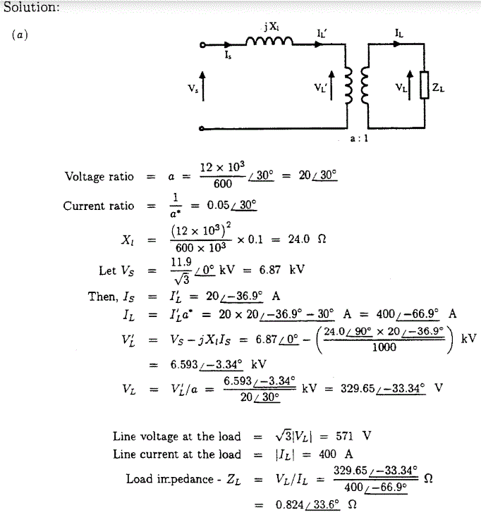

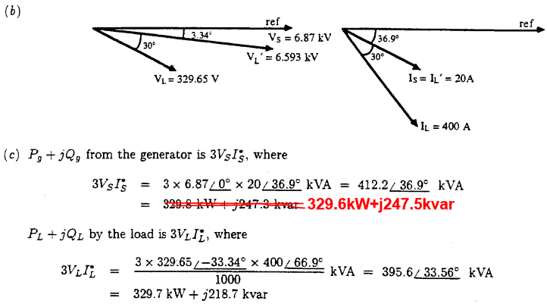

3.27

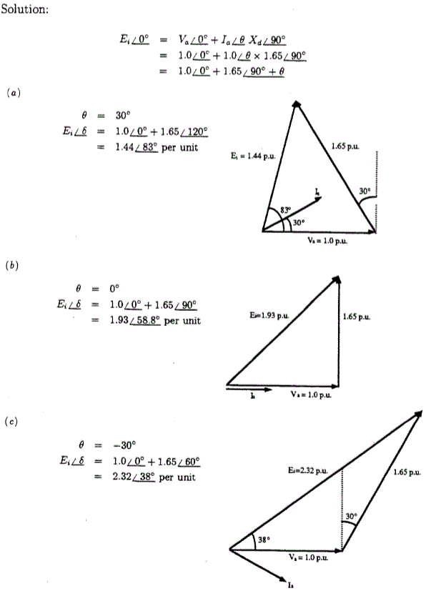

3.31

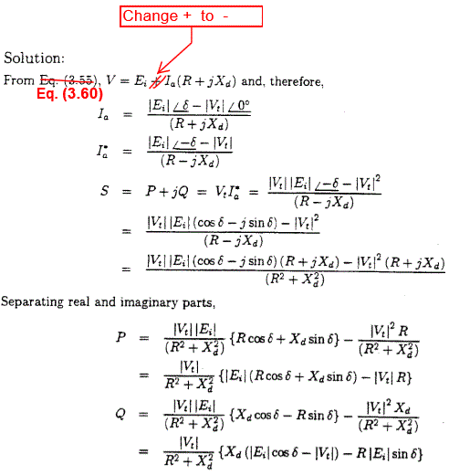

3.33(a)

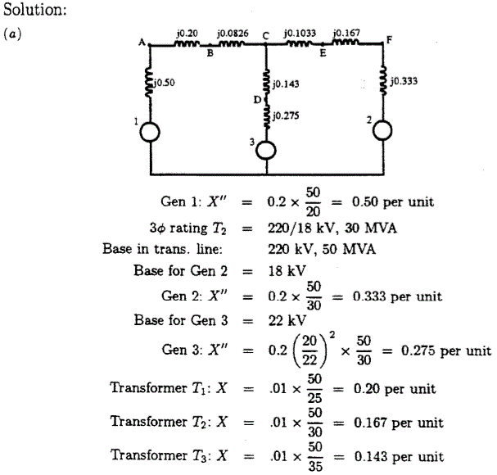

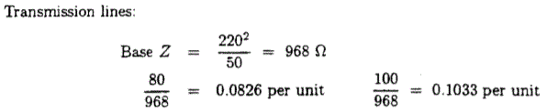

Problems: 5.3, 5.4, 5.8, 5.10, 5.12, 5.16

5.3

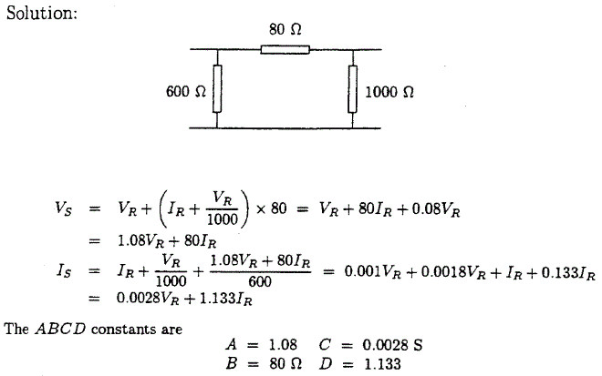

5.4

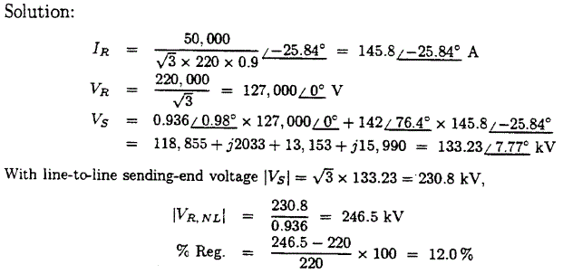

5.8

**Solution:**









When the receiving end is open circuited, .Then,



Hence, at the sending end (taking the receiving-end line as reference), the line-to-line voltages and currents are



(The  angle in the denominator of the second fraction of the current equations above represents a phase/line V conversion.)





where all angles are expressed with respect to receiving-end line voltage.

5.10

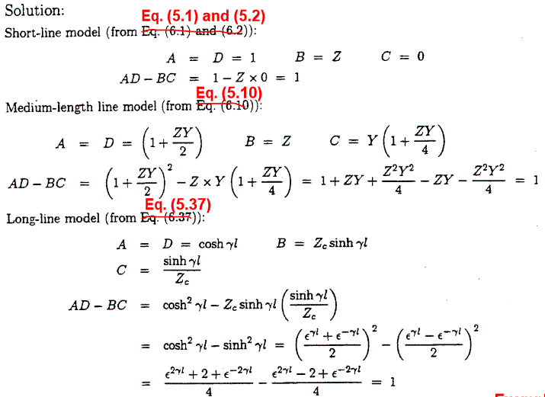

5.12

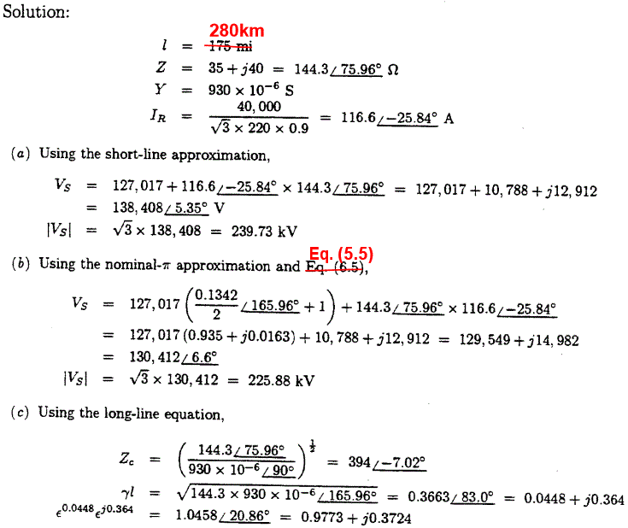

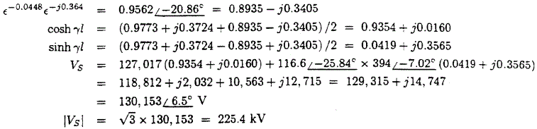

5.16

